SIMATS ENGINEERING
ASSESSMENT TOOL 2

COURSE NAME: Artificial Intelligence COURSE CODE: CSA17

COURSE OUTCOME COVERED

CO1: Apply AI basics such as intelligent agents and uninformed search methods to solve problems effectively.( BL3)

Assessment Tool Weightage: 35%

QUESTIONS: 2 Duration : 1 Hour
Total Marks:20

Annexure A

Constraint-Based Problem Solving

Code of Conduct:

I ____________________ (Name / Reg No) certify that this submission is my original work and that I have adhered to the guidelines specified for this assessment.
I understand that any violation of academic integrity rules will result in disciplinary action.

Signature of the student:

192412398
B.NANI GANGA PRASAD

Annexure A

CO1 Assessment: Constraint-Based Problem Solving

3. Autonomous Rescue Robot (Online Search in a Partially Observable Environment)
An autonomous rescue robot is deployed in a disaster-affected building to locate and rescue survivors. It operates in a partially observable environment where some paths are blocked, and it must make decisions with limited information. The building is represented as a grid of rooms. The robot starts at position S and must reach a survivor located at G.
Constraints:
- The robot can move up, down, left and right.
- Some cells are blocked (obstacles) and cannot be traversed.
- The robot has limited sensing capability (it can only observe adjacent cells).
- Each movement costs 1, but entering a risky zone costs an additional 2.
- The robot must minimise total cost while ensuring safe navigation.
- The robot must update its knowledge dynamically (online search scenario).
Tasks:
- Analyse all the given constraints and explain how they affect the robot's decision-making process.
- Develop a solution approach using an appropriate search strategy (e.g., Uniform Cost Search or an Online Search Agent). Clearly explain the steps involved.
- Demonstrate how the robot applies the AI concepts of intelligent agents, rationality and environment type.
- Justify why your chosen approach is the most suitable for solving this problem under the given constraints.
ANS:
a) Analysis of Constraints
- Movement: The robot can move up, down, left, and right. It cannot move diagonally.
- Obstacles: Blocked cells cannot be crossed, so the robot must find an alternative path.
- Limited sensing: The robot can observe only adjacent cells and does not know the complete environment initially.
- Movement cost: Each movement costs 1 unit, while entering a risky zone costs an additional 2 units. Therefore, the total cost of entering a risky cell is 3.
- Minimum cost: The robot must select the safest path with the lowest total movement cost.
- Dynamic knowledge: The robot updates its map whenever it discovers new obstacles or risky zones.
Conclusion: The robot must continuously observe, plan, move, and update its knowledge to reach the survivor safely and efficiently.
b) Solution Using Uniform Cost Search (UCS) and Online Search
Chosen approach: Uniform Cost Search combined with an online search agent.
UCS selects the path with the lowest accumulated cost, while the online agent discovers the environment step by step.
Steps involved
- Start the robot at position S and initialise the known map.
- Observe the adjacent cells.
- Identify blocked cells, safe cells, and risky zones.
- Calculate the movement cost for each available path.
- Select the path with the lowest total cost using UCS.
- Move one step and observe the surroundings again.
- Update the map when new information is discovered.
- Repeat the process until the robot reaches goal G.
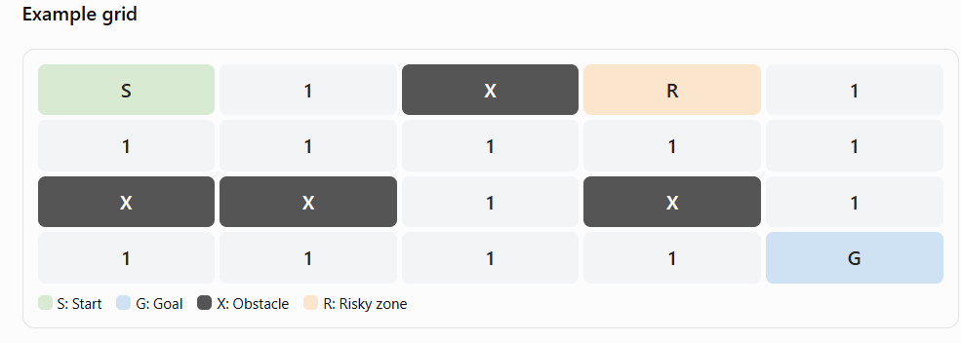

Illustrative grid: each numbered cell is a traversable cell with movement cost 1. The robot discovers cells as it explores.
Cost calculation:
- Safe cell: $1$
- Risky cell: $1+2=3$
- Obstacle: Cannot enter
The UCS algorithm maintains a priority queue and expands the available position with the lowest accumulated cost. When new information changes the map, the robot updates its plan and continues navigating.
c) AI Concepts Used
1. Intelligent agent
The robot is an intelligent agent because it senses its surroundings, makes decisions, and performs actions to rescue the survivor.
2. Rationality
A rational robot chooses actions that minimise total travel cost while avoiding obstacles and unnecessary risks, based on the information currently available.
3. Environment type
Environment property | Classification
Observability | Partially observable
Predictability | Stochastic if conditions or outcomes can change unpredictably; otherwise deterministic
Task structure | Sequential
Environment changes | Dynamic if hazards or obstacles can change during operation
State space | Discrete
Number of agents | Single-agent
d) Justification for the Chosen Approach
- Lowest cost: UCS finds the minimum-cost path when movement costs are non-negative.
- Risk awareness: It accounts for the additional cost of risky zones.
- Obstacle avoidance: It excludes known blocked cells from the available paths.
- Online learning: The robot can update its map as new information becomes available.
- Safe navigation: It can avoid known hazards and replan when new obstacles are discovered.
Conclusion: Uniform Cost Search combined with an online search agent is suitable because it supports cost-based path selection and continuous adaptation to incomplete information. However, UCS alone does not guarantee safety; the robot must also use hazard detection and replan whenever new information is discovered.

5. 4×4 Sudoku (Constraint Propagation with AC-3)
Fill the grid so that every row, every column and every 2×2 box contains the digits 1–4 exactly once. Blank cells are shown as –.
– | 2 | – | –
3 | – | – | 2
– | – | 4 | –
4 | – | – | 1

- Define the variables, domains and constraints (use the Alldiff constraint).
- Write the initial domain of every blank cell after removing values that conflict with the given digits.
- Apply arc consistency (AC-3) and show how the domains shrink.
- Complete the grid, using backtracking only if constraint propagation alone is not enough.
5. 4×4 Sudoku – Constraint Propagation with AC-3
i) Define variables, domains and constraints
Variables: XijX_{ij}Xij represents the cell in row iii and column jjj, where i,j=1,2,3,4i,j=1,2,3,4i,j=1,2,3,4.
Domains: Each blank cell has the domain
D={1,2,3,4}D=\{1,2,3,4\}D={1,2,3,4}
Constraints using AllDiff:
- Each row must contain different digits.
- Each column must contain different digits.
- Each 2×22\times22×2 box must contain different digits.
ii) Initial domains of blank cells
After removing digits that conflict with the given numbers:
Cell | Domain
X11X_{11}X11 | {1}\{1\}{1}
X13X_{13}X13 | {3}\{3\}{3}
X14X_{14}X14 | {1,3,4}\{1,3,4\}{1,3,4}
X22X_{22}X22 | {1,4}\{1,4\}{1,4}
X23X_{23}X23 | ∅\varnothing∅
X31X_{31}X31 | {1,2}\{1,2\}{1,2}
X32X_{32}X32 | {1,3}\{1,3\}{1,3}
X34X_{34}X34 | {2,3}\{2,3\}{2,3}
X42X_{42}X42 | {3}\{3\}{3}
X43X_{43}X43 | {2,3}\{2,3\}{2,3}
iii) Apply Arc Consistency (AC-3)
AC-3 removes values that violate the constraints between connected cells.
- X11={1}X_{11}=\{1\}X11={1}, so X13X_{13}X13 cannot contain 1. Therefore, D(X13)={3}D(X_{13})=\{3\}D(X13)={3}.
- X13=3X_{13}=3X13=3, so X14X_{14}X14 cannot contain 3. Thus, D(X14)={4}D(X_{14})=\{4\}D(X14)={4}.
- X23={1}X_{23}=\{1\}X23={1}, because row 2 contains 3 and 2, and column 3 contains 4.
- X22={1,4}X_{22}=\{1,4\}X22={1,4}. Since X23=1X_{23}=1X23=1, D(X22)={4}D(X_{22})=\{4\}D(X22)={4}.
- X31={1,2}X_{31}=\{1,2\}X31={1,2}. Since X11=1X_{11}=1X11=1, D(X31)={2}D(X_{31})=\{2\}D(X31)={2}.
- X32={1,3}X_{32}=\{1,3\}X32={1,3}. Since X22=4X_{22}=4X22=4 and X42=3X_{42}=3X42=3, D(X32)={1}D(X_{32})=\{1\}D(X32)={1}.
- The remaining blank cells are determined by the row and column constraints.
iv) Final solved Sudoku grid

Conclusion: AC-3 reduces the domains using row, column, and box constraints. The resulting grid satisfies all the Sudoku rules, so backtracking is not required.

7. Ambulance Routing During Floods (A* Search with a Road-Closure Constraint)
An ambulance must travel from the accident site S to the hospital G. Because of flooding, the road B–D is closed and cannot be used. The road costs (travel time in minutes) are:
Road | Cost | Road | Cost
S–A | 3 | C–D | 2
S–B | 2 | C–E | 3
A–C | 4 | D–G | 2
B–C | 1 | E–G | 4
B–D | 2 (closed)

Heuristic values (straight-line time to G): h(S)=6, h(A)=6, h(B)=4, h(C)=4, h(D)=2, h(E)=3, h(G)=0.
- Apply A* search and show the open and closed lists, with g, h and f values, at each step.
- Give the route found and its total cost. iii. Find the route and cost that A* would return if road B–D were open. iv. Check whether the heuristic is admissible and consistent for the flooded network.
Given: Road B–D is closed. The ambulance must travel from S to G with minimum travel time.
A* evaluation formula:
$$\boxed{f\left(n\right)=g\left(n\right)+h\left(n\right)}$$
Where:
- $g\left(n\right)$= actual cost from start S to node $n$.
- $h\left(n\right)$= estimated cost from node $n$to goal G.
- $f\left(n\right)$= estimated total cost.
i) Apply A* Search
Step 1: Start at S
$$g\left(S\right)=0, h\left(S\right)=6, f\left(S\right)=0+6=6$$
Open list: S(0, 6, 6)
Closed list: Empty
Step 2: Expand S
Available roads: S–A (cost 3) and S–B (cost 2).
For A:
$$g\left(A\right)=3, f\left(A\right)=3+6=9$$
For B:
$$g\left(B\right)=2, f\left(B\right)=2+4=6$$
Open list: B(2, 4, 6), A(3, 6, 9)
Closed list: S
Step 3: Expand B
Road B–D is closed. Only B–C is available.
$$g\left(C\right)=2+1=3$$
$$f\left(C\right)=3+4=7$$
Open list: C(3, 4, 7), A(3, 6, 9)
Closed list: S, B
Step 4: Expand C
Available roads: C–D (cost 2) and C–E (cost 3).
For D:
$$g\left(D\right)=3+2=5, f\left(D\right)=5+2=7$$
For E:
$$g\left(E\right)=3+3=6, f\left(E\right)=6+3=9$$
Open list: D(5, 2, 7), A(3, 6, 9), E(6, 3, 9)
Closed list: S, B, C
Step 5: Expand D
Road D–G costs 2.
$$g\left(G\right)=5+2=7$$
$$f\left(G\right)=7+0=7$$
Open list: G(7, 0, 7), A(3, 6, 9), E(6, 3, 9)
Closed list: S, B, C, D
G is the goal, so stop.
ii) Final route and total cost
$$\boxed{S→B→C→D→G}$$
Total cost:
$$=2+1+2+2$$
$$\boxed{\text{Total cost}=7\text{ minutes}}$$
iii) If road B–D were open
The route would be:
$$S→B→D→G$$
Total cost:
$$=2+2+2$$
$$\boxed{\text{Total cost}=6\text{ minutes}}$$
iv) Check admissibility and consistency
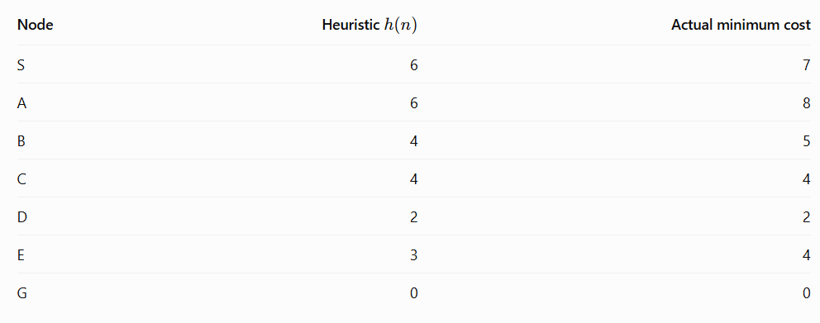Since $h\left(n\right)$is less than or equal to the actual minimum cost for every node, the heuristic is admissible.
Consistency: A heuristic is consistent if
$$h\left(n\right)≤c\left(n , n^{'}\right)+h\left(n^{'}\right)$$
For example, for C–D:
$$h\left(C\right)≤c\left(C , D\right)+h\left(D\right)$$
$$4≤2+2$$
$$4≤4 ✓$$
The same condition holds for all other available roads. Therefore, the heuristic is consistent for the flooded network.

8. 4-Queens Problem (Local Search with Min-Conflicts)
Place 4 queens on a 4×4 board so that no two queens attack each other. Each column holds exactly one queen. The initial state has the queens in rows (1, 3, 4, 2) for columns 1 to 4 respectively, with row 1 at the top.
i. Formulate the problem as a CSP: variables, domains and constraints. ii. Draw the initial board and count the number of conflicts for each queen.
- Apply the Min-Conflicts algorithm: at each step pick the leftmost queen in conflict and move it to the row with the fewest conflicts (break ties by choosing the lowest row number). Show the board and conflict counts after every move.
- State the final solution and explain why Min-Conflicts works well for large nQueens problems.
i) Formulate the problem as a CSP
Variables: $Q_{1},Q_{2},Q_{3},Q_{4}$, representing the queen positions in columns 1–4.
Domains: Each queen can occupy any row:
$$D\left(Q_{i}\right)=\left\{1 , 2 , 3 , 4\right\}$$
Constraints:
- No two queens occupy the same row.
- No two queens occupy the same diagonal.
- Each column contains exactly one queen.
ii) Initial board and conflicts
Initial state: $\left(1 , 3 , 4 , 2\right)$.

Only $Q_{2}$and $Q_{3}$attack each other diagonally.
$$\boxed{\text{Initial conflicts}=1}$$
iii) Apply the Min-Conflicts algorithm
Move 1: The leftmost queen in conflict is $Q_{2}$, currently in row 3.
The minimum-conflict rows are 1, 3 and 4. Choose the lowest row number, row 1.
New state:
$$\left(1 , 1 , 4 , 2\right)$$
Conflicts: 1 (the queens in columns 1 and 2 share row 1).
Move 2: The leftmost queen in conflict is now $Q_{1}$, in row 1.
Choose the row with the fewest conflicts for $Q_{1}$. Row 3 has zero conflicts.
New state:
$$\boxed{\left(3 , 1 , 4 , 2\right)}$$
Conflicts: 0.
iv) Final solution and conclusion


Final positions:
$$\boxed{\left(3 , 1 , 4 , 2\right)}$$
All four queens are in different rows and columns, and no two share a diagonal. Therefore, the solution has zero conflicts.
Why Min-Conflicts works well for large N-Queens problems: It selects a queen in conflict and moves it to a position with fewer conflicts. This reduces unnecessary searching and makes it efficient for large boards.

RUBRICS FOR CALCULATION:

Criteria | Weightage | Level 4 (Exemplary) | Level 3 (Proficient) | Level 2 (Developing) | Level 1 (Beginning)
Problem  Understanding | 25% | Clearly defines the problem and  identifies all relevant constraints accurately | Identifies most constraints with minor gaps | Partial understanding; misses key constraints | Fails to identify  constraints correctly
Constraint Analysis | 25% | Analyzes constraints effectively and prioritizes them logically | Provides reasonable  analysis with some  prioritization | Limited analysis; weak  prioritization | No meaningful analysis or prioritization
Solution  Development | 25% | Develops optimal and feasible solutions satisfying all constraints | Develops workable solutions with minor limitations | Solutions partially satisfy constraints | Solutions do not meet constraints
Application of  Concepts | 15% | Effectively applies appropriate concepts, methods, or tools | Applies concepts with minor errors | Limited application; requires guidance | Unable to apply  relevant concepts
Justification | 10% | Provides strong justification for decisions with logical reasoning | Provides  justification with some clarity | Weak or unclear  justification | No  justification provided

